***Creating an EC2 Service in AWS:***

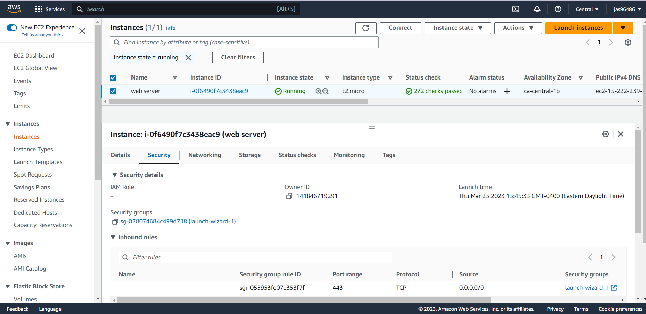

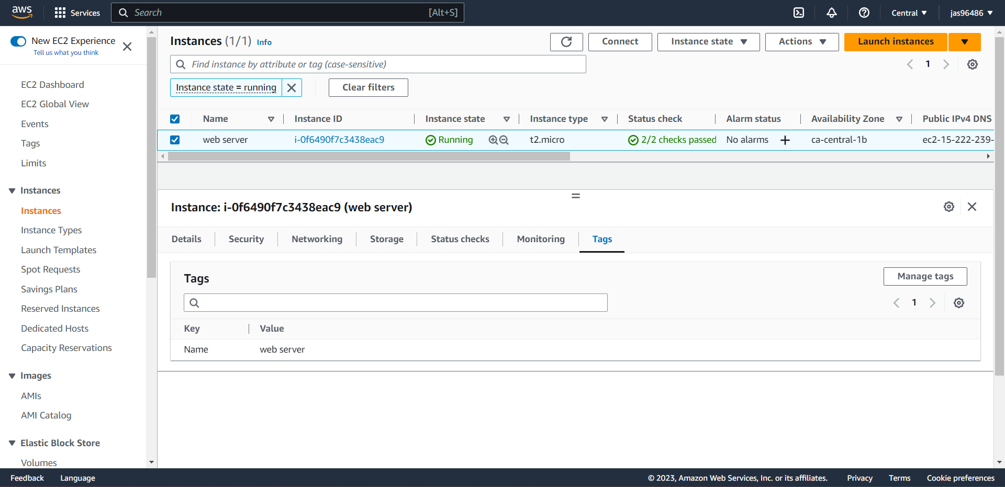

***Creating an S3 Service in AWS:***

